BRETTYOUNG SEEDS LTD.
PO Box 99 St. Norbert Postal Station
Winnipeg, MB R3V 1L5
http://www.brettyoung.ca
Available to:
- Alberta
- British Columbia
- Central Ontario
- Eastern Ontario/Outaouais
- Prairie
- Southwestern Ontario
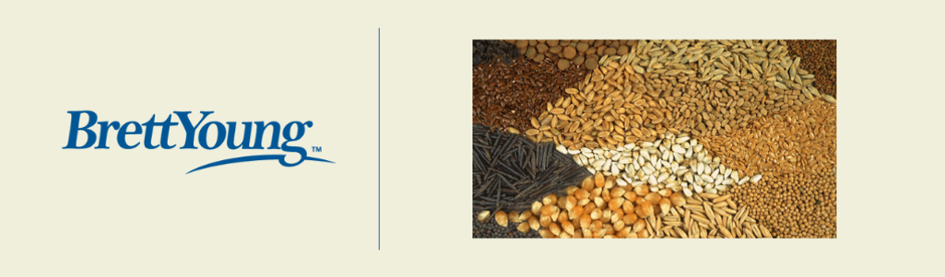
2% discount at invoice on professional turf products.

BrettYoung is a major supplier of turf products throughout Canada with distribution in Winnipeg, MB.; Saskatoon, SK.; Leduc, AB; Calgary AB.; Vancouver, BC; and Ontario CGSA members receive a 2% discount at invoice on professional turf products.

PRODUCTS & SERVICES
- Agronomic Testing
- Fertilizer
- Accessories
- Soil Amendments
- Erosion Control Products
- Equipment
- Control Products
- Turf and Native Seed

CONTACT
Contact a sales representative in your area to find out more:
REGIONAL SALES REPRESENTATIVES
British Columbia  Duane Sharpe • Sales Manager  604-417-9917 | EMAIL DUANE | Ontario  Andrew Hardy • Sales Manager  647-241-1134 | EMAIL ANDREW
Interior & Northern British Columbia  Pat Johnson  250-317-4170 | EMAIL PAT | GTA/Niagara  Chris Nelson  416-500-5233 | EMAIL CHRIS
Lower Mainland British Columbia  Everett Nieuwkoop  604-615-1867 | EMAIL EVERETT | Western Ontario  Joel Archambault  519-688-4397 | EMAIL JOEL
Alberta  Cory Becker • Sales Manager  587-989-5035 | EMAIL COREY | Southwestern Ontario  Kelly Barnet  519-890-4061 | EMAIL KELLY
Northern Alberta  Trevor Gibson  780-718-5132 | EMAIL TREVOR | Northern Ontario  Steve Hewgill  705-896-2148 | EMAIL STEVE
Southern Alberta  Shawn Marjoram  587-999-5546 | EMAIL SHAWN | Central & Eastern Ontario  Ron Milne  905-213-5710 | EMAIL RON
Prairies  Joe Chartrand • Sales Manager  204-212-0226 | EMAIL JOE | Professional Turf and Reclamation  Ashley Schmidt • Product Manager  204-807-4753 | EMAIL ASHLEY
Saskatchewan  Keith Bell  306-381-4283 | EMAIL KEITH | Professional Turf and Reclamation  Travis Unger • Vice President  780-886-9661 | EMAIL TRAVIS
Manitoba | NW Ontario  Mark Smith  431-373-1529 | EMAIL MARK | Professional Turf and Reclamation  Karen Green • Administrator  204-478-2248 | EMAIL KAREN

